FFT Algorithm for multiplication of polynomials

Anjani Kumar (11101)

Sumedh Masulkar (11736)

* **System Details:**
* Processor Name – Intel(R) Xeon(R) CPU E5-2620.
* Processor Speed – 2.00GHz.
* RAM – 32GB.
* 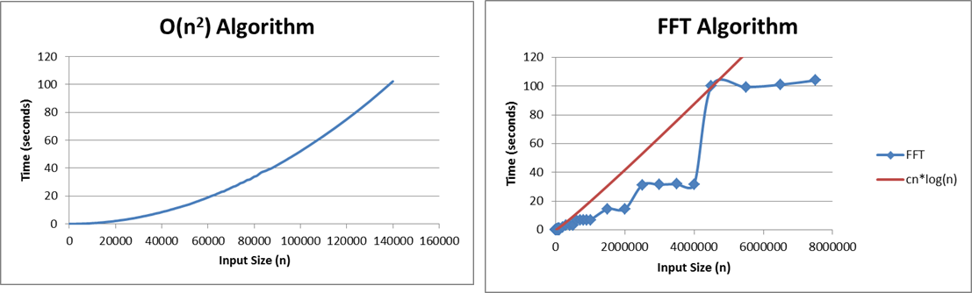**Plots showing comparison of the algorithms:**
* **Observation:**
* As can be seen from the above plots, FFT algorithm is much faster than the trivial algorithm for multiplication of polynomials for large sized inputs.
* **Largest values of n for which algorithm returns answer in:**

|  |  |  |  |
| --- | --- | --- | --- |
| S.no. | Time (seconds) | n (Trivial algorithm) | n (FFT algorithm) |
| 1. | 1 seconds | 15000 | 150000 |
| 2. | 10 seconds | 44000 | 1200000 |
| 3. | 1 minute | 110000 | 4200000 |